**EEL 5718 Project Report 1: Project Proposal**

1. **Team Members:**
2. Xi Yang (UFID: 16216573)
3. Jincheng Xu (UFID: 90898935)
4. Juechen Liu (UFID: 51506194)
5. **Selected Topic and Paper**

***Topic***

Among the list of topics provided, we decide to choose *Online Social Netwoks* as our project topic.

***Paper***

We selected a paper with information listed as follow:

Title: *Socio-Geo: Social Network Routing Protocol in Delay Tolerant Networks*

Author list: Seungbae Kim, Mario Gerla

Affiliation: Department of Computer Science, University of California, Los Angeles

Published In: Computing, Networking and Communications (ICNC), 2016 International Conference on

Date: Feb. 2016

Publisher: IEEE

***Abstract***

Social based routing has emerged as one of the most efficient routing solutions for Delay Tolerant Networks. It opportunistically relays data to more sociable nodes that have a higher probability of meeting the destination. Many researchers have tried to find the most appropriate metrics that can reflect the real world, such as frequency, freshness, and/or centrality. However, these metrics are mainly used to represent sociality between nodes without considering the actual social relationship between people. In this paper, we propose a novel social network routing protocol that exploits the human friendship information in order to perform routing. First, by collecting data from online social network services, we generated a new dataset trace that includes real social relation information in addition to users' mobility patterns. With the geolocation information that incorporates social relationship information, our protocol can improve the probability estimate of encountering destinations and deliver data packets.

***Paper link*** http://ieeexplore.ieee.org/stamp/stamp.jsp?arnumber=7923427&tag=1

1. **Selected Simulator**

We are going to use NS3 as the simulator for the project. The NS3 simulator is a discrete-event network simulator and free for education use. This tool is sufficient for us to simulate the network behaviors of the online social networks.

1. **Project plan**

The paper we cited described a new protocol namely Socio-Geo. This novel protocol is designed as an efficient routing solution for Delay or Disruption Tolerated Networks (DTN) by exploiting the human friendship information. In the *Socio-Geo* protocol, two social routing metrics are defined as *encounter probability* and *encounter count*. These two metrics have never been used together in the previous research which characterize the innovation of this paper. For forwarding strategy, the *Socio-Geo* protocol utilizes two sequential phases specifically message dissemination and socio-geo forwarding. To test the new protocol and compare it with other protocols, the authors created a dataset of 80 nodes (representing 80 users) with their mobility patterns and social relationship information. The authors evaluated the performance of the *Socio-Geo* protocol and other protocols (*Max Pr*, *Epidemic*, *Spray & Wait*) in ONE simulator. The conclusion obtained from simulation indicated that the delivery probability of *Socio-Geo* is 5% better than the best of the rest. Also, Socio-Geo has low network overhead compared with other routing protocols.

This new protocol is very interesting because it provides a strong evidence that mobility patterns of mobile devices are important to design protocols in DTN and can effectively improve the routing performance by considering users’ social relationships and behaviors. The authors simulate the performance of the protocol on ONE simulator which is a Java platform. Our project is designed to confirm the author’s conclusion by transport the protocol simulation from ONE platform to NS3 platform and possibly enlarge the datasets volume.

To start our project, we are going to implement the Socio-Geo protocol in NS3 simulator. The second step is reconstructing the dataset to include more nodes and make the dataset more complicated by tuning the parameters. Then we are going to run the simulation using the new dataset with *Socio-Geo* and another one protocol (not decided yet but probably *Spray and Wait*) and compare the results we obtained to confirm that the new protocol performs better than the other.

Functions in simulation:

1. Nodes function. We need this function to simulate the moving behaviors of each node in our simulation mode. The mobility pattern will be defined by this function.
2. Node meet probability function. We must define a function to calculate the probability that all nodes meet each other. The data collected from this function will be an important parameter for the forwarding function.
3. Message forwarding function. We need to define how messages been forwarded by each node. This is the most important function we need to implement because most of the evaluation data will be extract from the simulation result of this function. We will follow the Message forwarding algorithm (Fig. 1) presented in the paper for implementation.

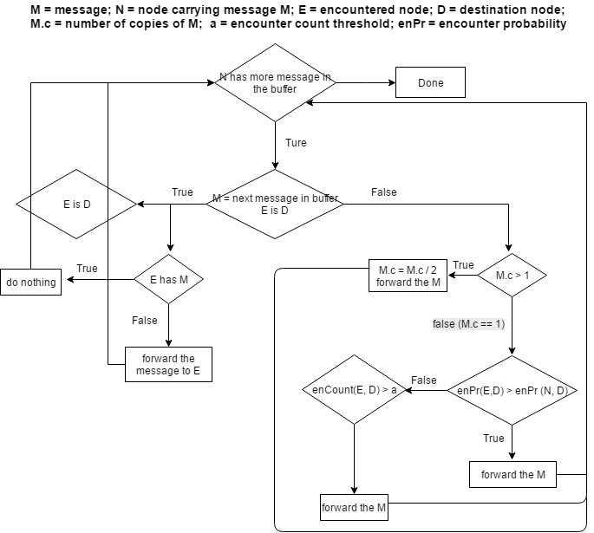

Figure . Forwarding algorithm diagram.

1. Topology function. We need to define an DTN environment for the simulation.

Modules will be used in ns3:

1. Mobility module. We need this module to simulate the nodes mobility pattern. The functions we need in this module is to simulate movement pattern for each node in the dataset. The classes we are going to use including ns3::Rectangle, ns3::ListPositionAllocator, ns3::RandomWalk2dMobilityModel, and ns3::MobilityHelper etc.
2. Point-To-Point Network Device module. We need this module to set up all users as mobile devices. The class we need is ns3::PointToPointNetDevice.
3. Point-To-Point Layout Helpers. We might need to simulate all nodes in a grid topology. Therefore, we need class ns3::PointToPointGridHelper to create grid topology with p2p links
4. Statistics module. We need to obtain the data transition analysis and delay analysis. The classes we are going to use ns3::DelayJitterEstimation, ns3::PacketCounterCalculator and ns3::StatisticalSummary.
5. Flow Monitor module. Since we are measuring DTN protocol so we need to assess the delay improvement. The class we need is ns3::FlowMonitor.
6. **Milestones**

The milestones of the project are briefly described in the table below:

|  |  |  |
| --- | --- | --- |
| Milestone | Deadline | Description |
| Accumulation of background knowledge and information of the project (such as how to code in NS3) | June 5th | Understanding how ns3 works with mobility pattern module. Obtaining the details of the protocols we need to implement. Transferring code from java to C++. Obtaining the original dataset from the paper author. |
| Set up simulation environment | June 20th | Compiling the code on ns3 platform. Modifying the dataset to include more complicated pattern. Implement the functions we need for simulation. |
| Obtain simulation data | July 15th | Running simulation for a certain period and collecting the data. |
| Data analysis and final report | July 25th | Comparing the data and make a final report with a conclusion on performance of the *Socio-Geo* protocol. |

1. **Responsibilities**

Xi Yang is going to take the responsibility for function 1 and 2 and milestone 1 and 2.

Juechen Liu is going to take the responsibility for function 2 and 3 and milestone 2 and 3.

Jincheng Xu is going to take the responsibility for function 3 and 4 and the milestone 3 and 4.